**Gertrud Quarter Summary**

Gertrud is an automatic tester that measures the accuracy of Neura real-time events. In order to do so Gertrud compares the time of occurrence of real-time and timeline events (both of those events are continuously collected at Neura database).

Ratatouille is the event trigger that is integrated in Neura application and detects events real-time in the mobile. The first version of Ratatouille ran on production on Jan. 2015. Adoption of Ratatouille to Neura user is essential for detecting real-time events. The adoption percentage of Ratatouille over Neura users is presented on “Ratatouille Adoption Rate” where the x-axis represents the adoption on January, February, March, and April and the y-axis shows the percentage of Neura users that installed an app version with Ratatouille.

By the adoption graph we can see a fast adoption rate approximately 60% per-month between January and February. In addition, the adoption rate becomes flat on April with 80% adoption. The additional 20% of the users do not have Ratatouille, since most of them use Neura iPhone application (which does not has Ratatouille yet). Consequently, we can learn from the adoption rate that currently only 80% of Neura users are generating real-time events.

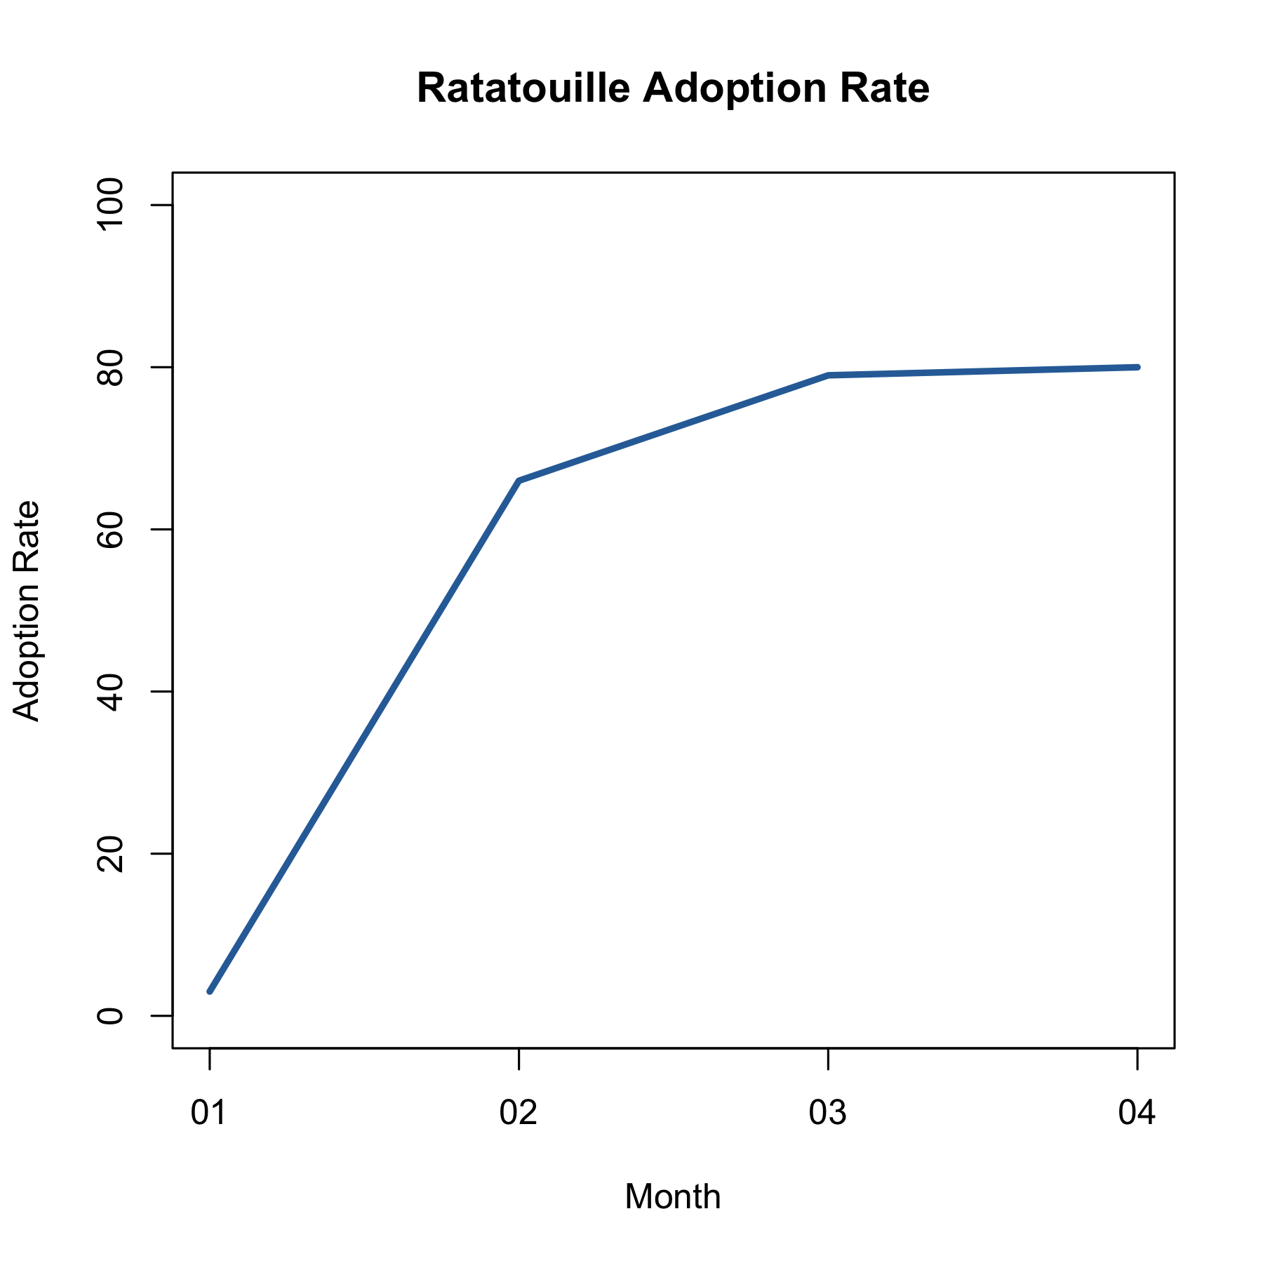

The basic metric for measuring real-time event performance is the accuracy level. The accuracy level is measured in percentage (0-100%), where the accuracy gets 0 when Neura missed all the occurrences and 100% when Neura detects all the occurrence of an event.

The next graph “Real-time events accuracy” shows the progress of Ratatouille during Q1. The x-axis shows the accuracy during each months January, February, March and April and the y-axis represents the distribution of the accuracy across all Neura events (e.g., “user start walking”, “user arrived at work”, “user wake up”, etc.). We later show how the accuracy is distributing over each event.

From the chart, we can see that on January the accuracy was very low at general. On February the accuracy level of the events jumps to almost 30% on average. On March the accuracy level gets to 50% and the variance of the accuracy is between 30% and 60%. On April the variance of the accuracy level decreases to 40% and 60%, since our stabilization process that included detection of events also with the server.

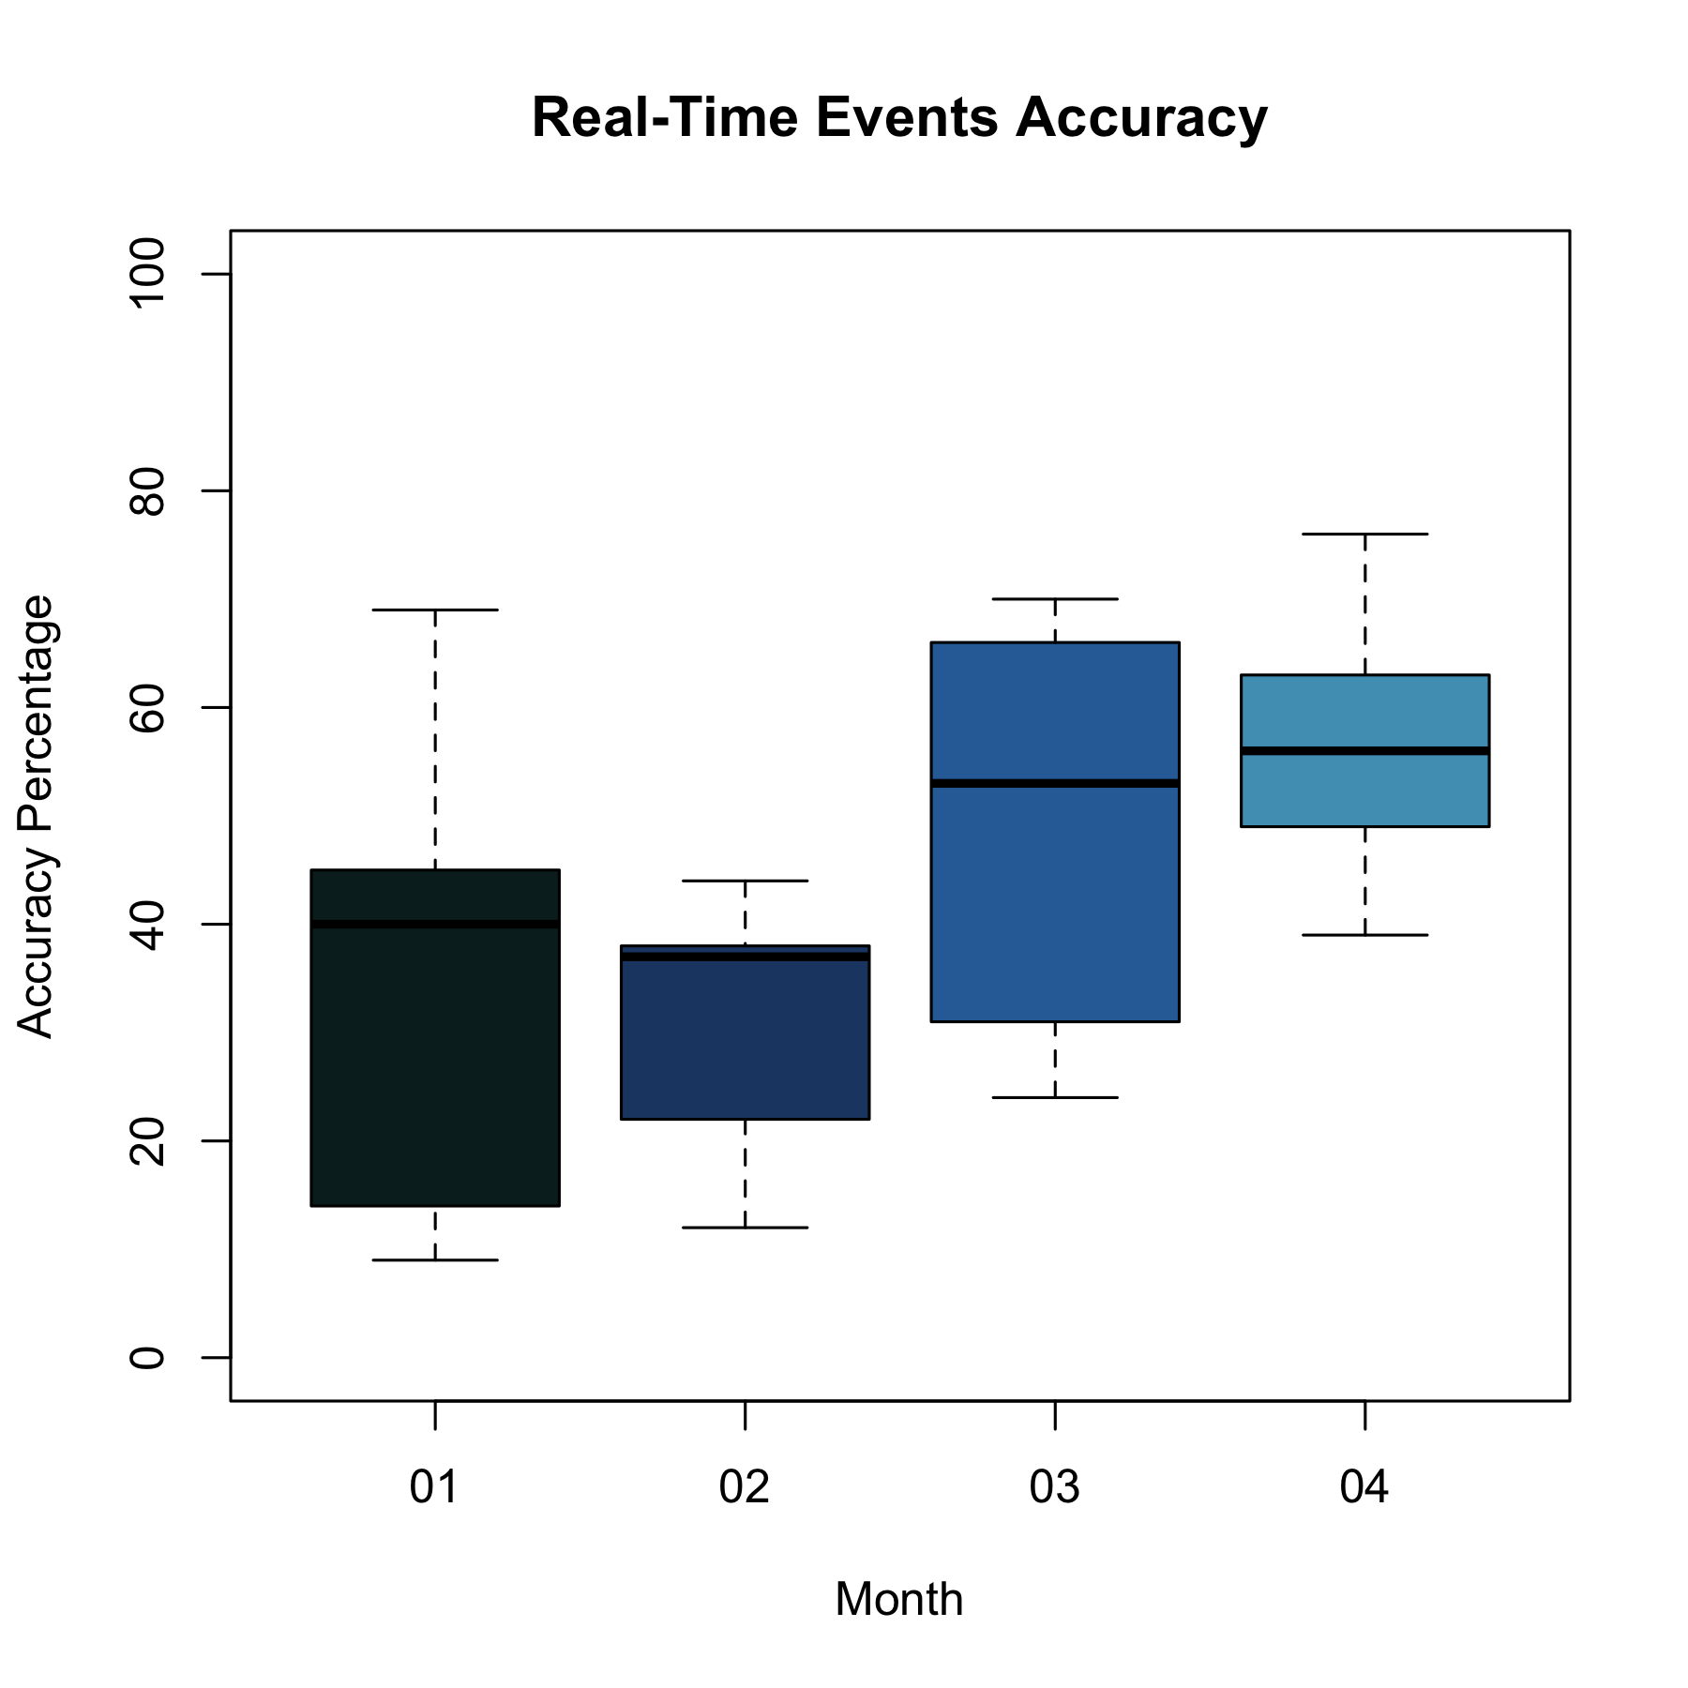

More low-level metrics are the True Positive and False Positive percentage. True Positive measures the percentage of the timeline events that were detected by Ratatouille on real-time. In other words, 0% indicates that Neura missed all the user’s events and 100% indicates that Neura detected all of them. In order to understand the False-Positive metric, we first define the False Negative metric. The False Negative percentage measures the number of Ratatouille mistakes, i.e., events that were detected wrongly on Ratatouille and do not actually occur. In this case, 0% indicates that Ratatouille has no mistakes and 100% indicates that every event that Ratatouille detects is wrong. The False Positive percentage is the inverse of the False Negative percentage in which 0% is the case where every event of Ratatouille is mistake and 100% where there are no mistakes.

The graphs “True-Positive Events” and “False-Positive Events” show the progress of these metrics on the January, February, March and April. It shows the distribution of the True-Positive percentage over all Neura events (“user start driving”, “user arrived at work”, etc.), where the horizontal line in each box represents the average value of the True-Positive percentage over all Neura events.

By the “True-Positive Events” graph, we can see the progress in Neura real-time engine, the True-Positive starts with 2% on January 20% on February 30% on March and gets to 40% on April. On the other hand, in False Positive we still don’t improve much. However, we decrease the False Positive variance as well.

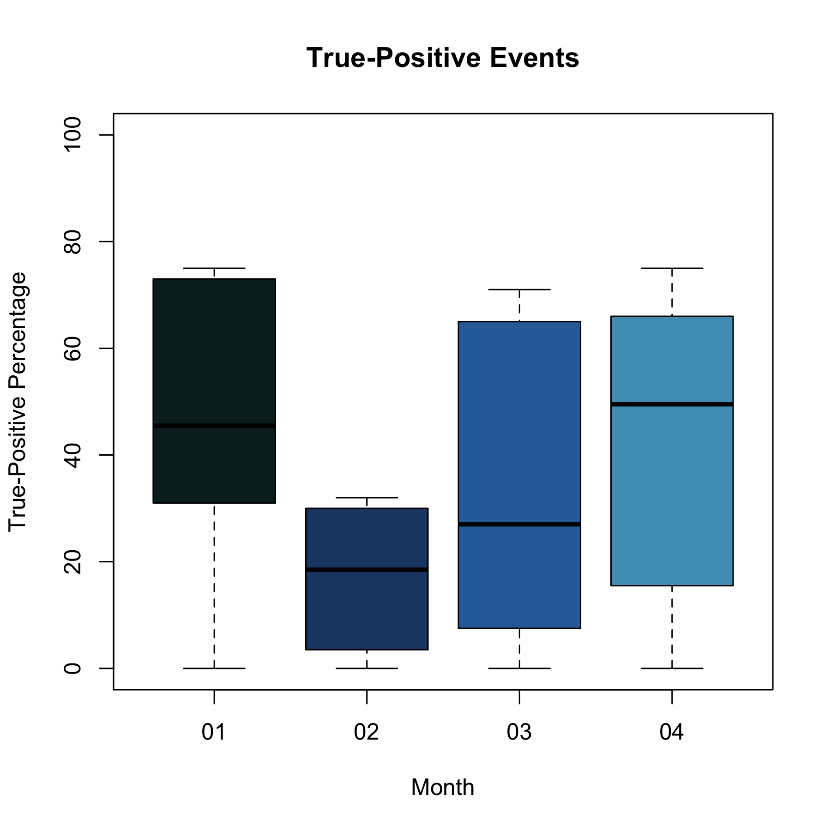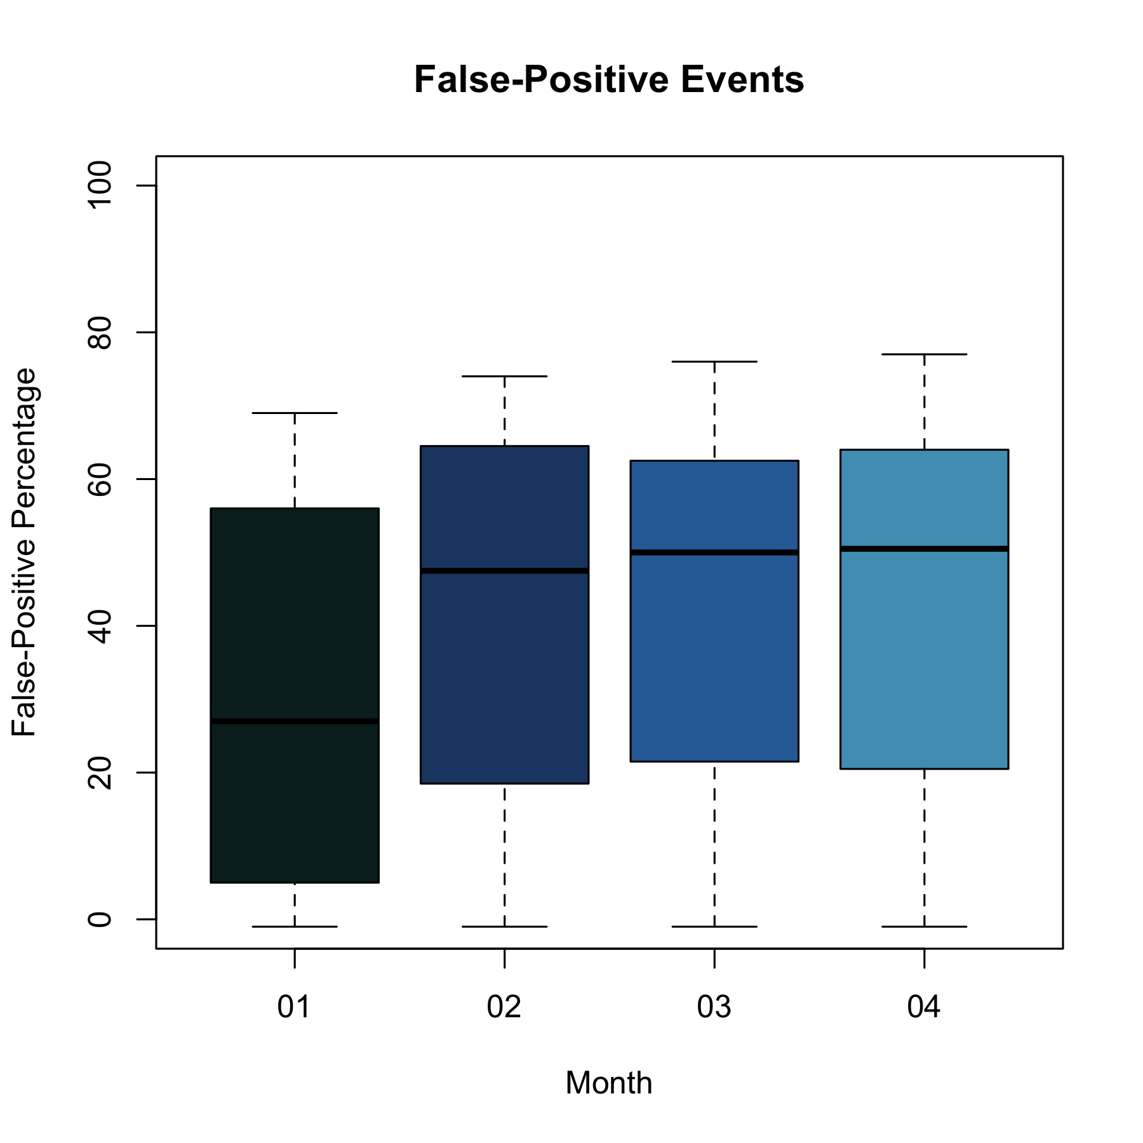

The graphs “Activities Events” and “Places Events” show the accuracy of the *activities’ events* such as “user started driving”, “user finished driving”, “user started walking”, etc. and *places’ events* such as “user arrived at work”, “user left work”, “user arrived home”, etc.

By the graphs the activities’ events are detected at a higher accuracy than the places’ activities. In particular, the detection accuracy of activities is around 60% while the places events are still on low accuracy of around 30%. The event that has the highest accuracy is “user started driving” and “user finished driving”. The event “user fell asleep” was not in the tested versions, and “user arrived at active-zone”, and “user left active-zone” did not occur.

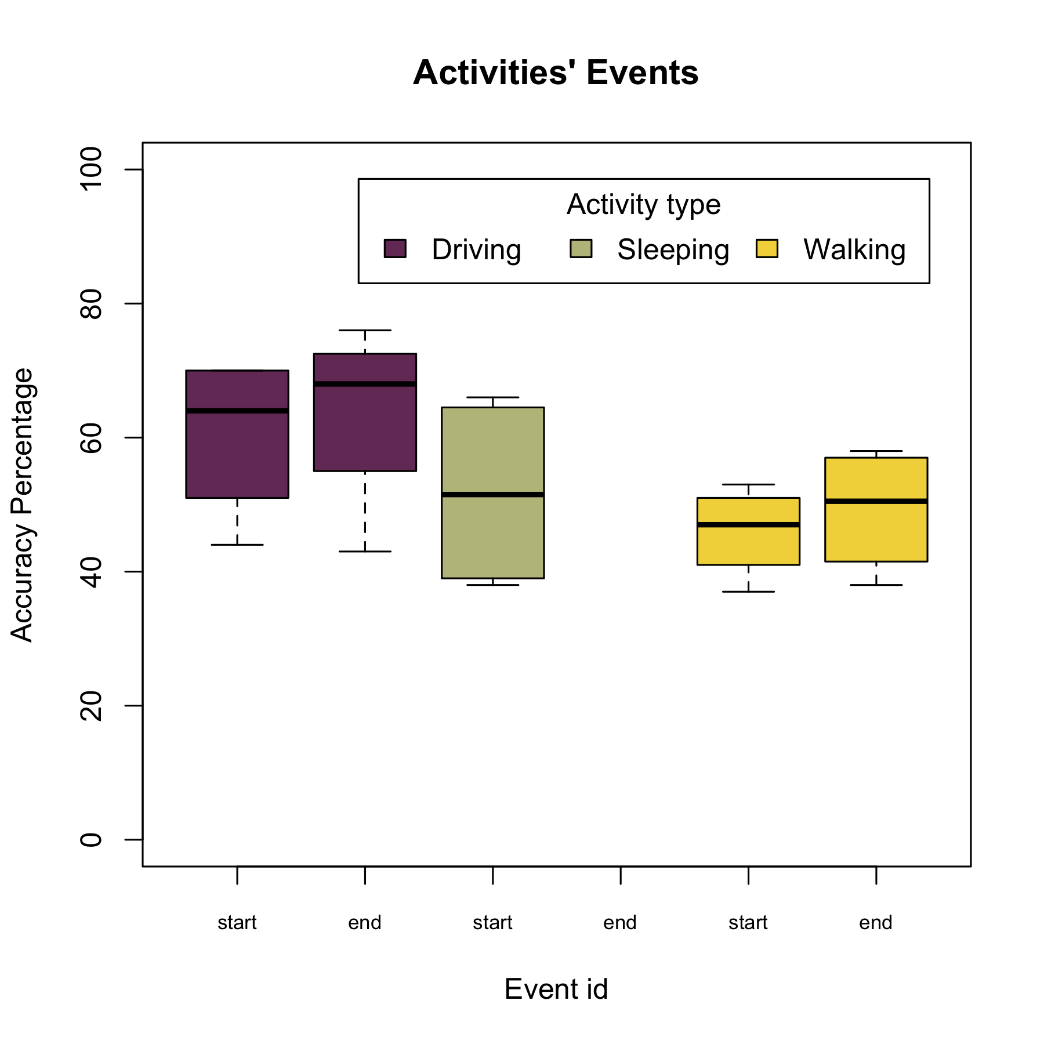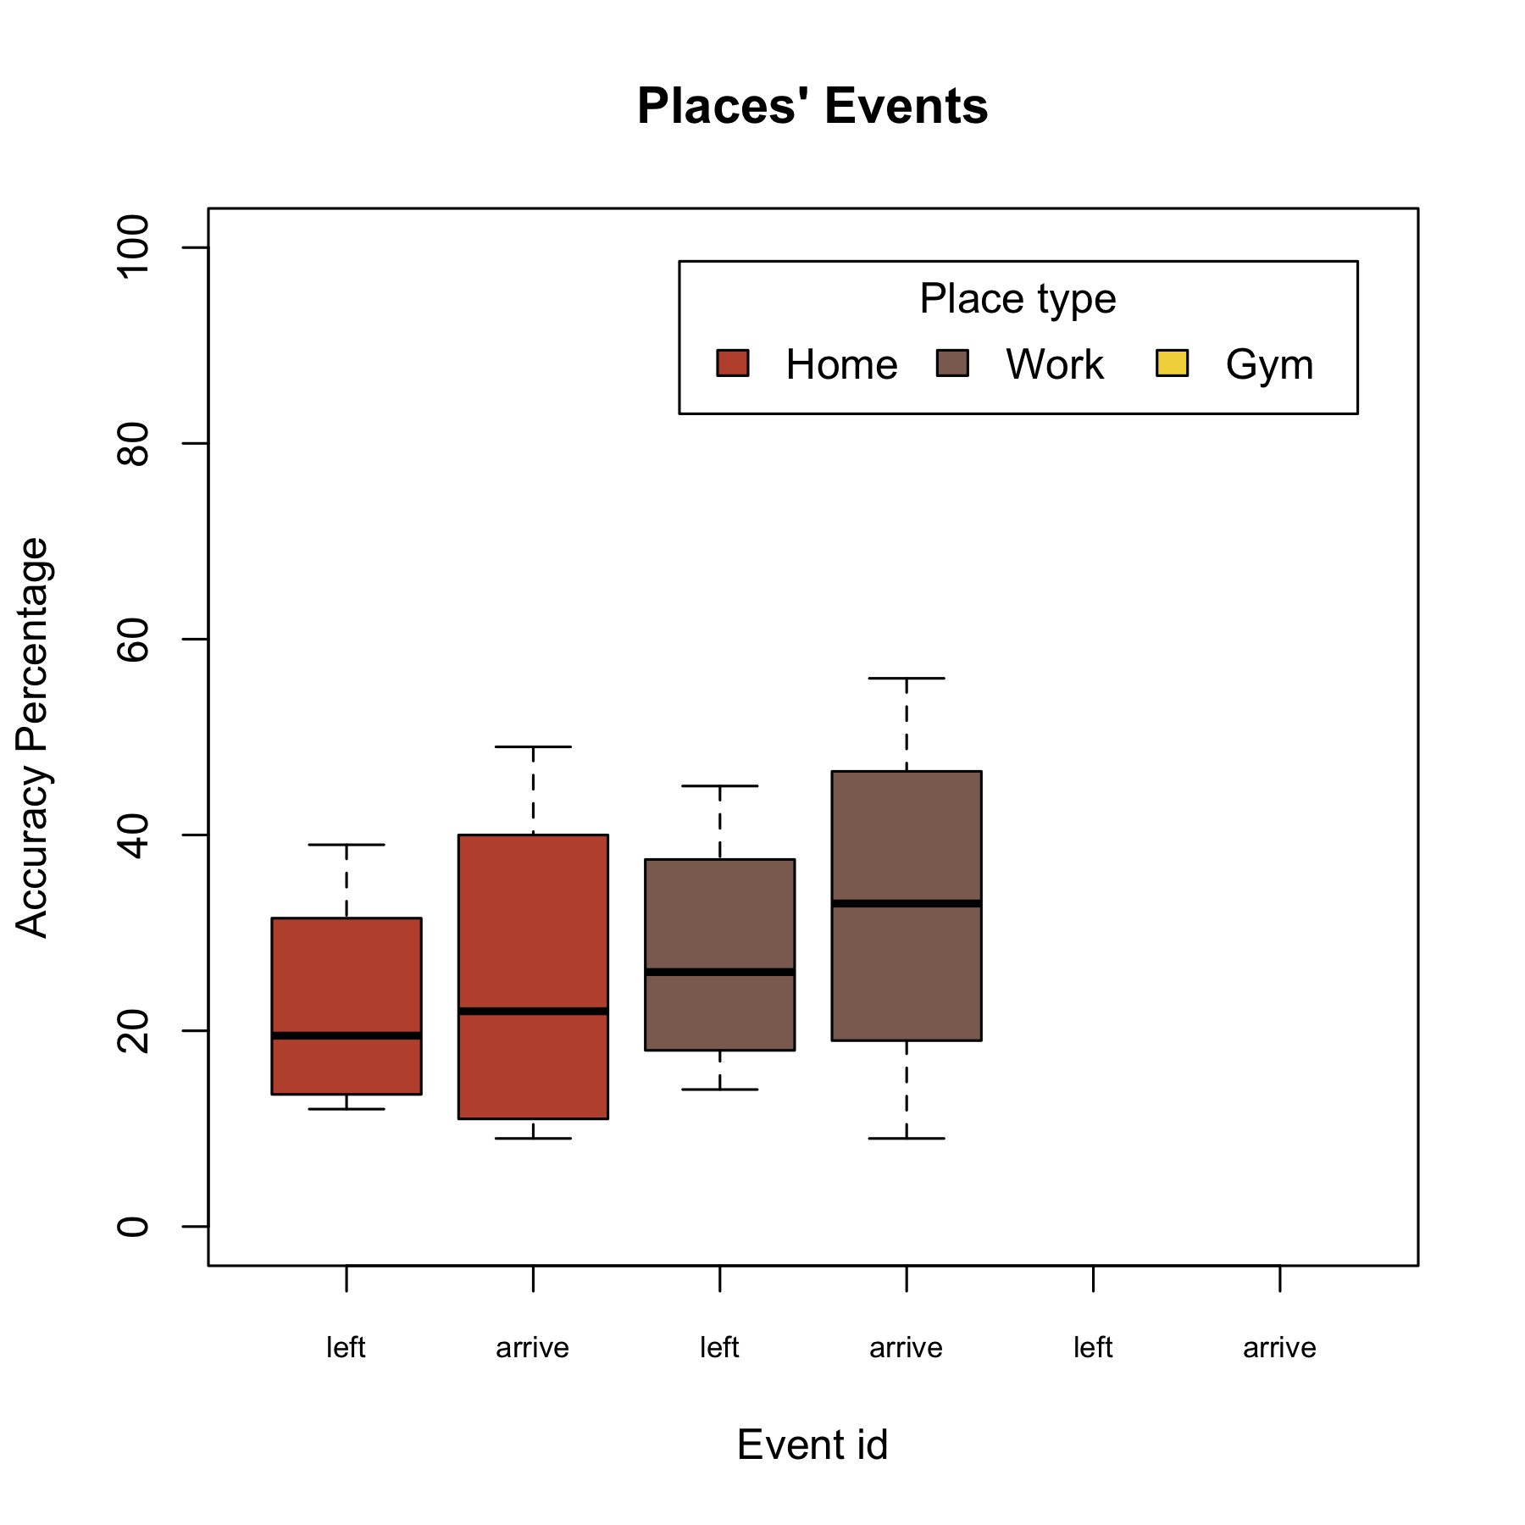

**Appendix - Gertrud raw results**

The following section summarizes the raw results of Gertrud. Each test result is summarized in a table with the following metrics:

* **The TR column**: the number of timeline events that detected by Rattatouille.
* **The T column**: the number of timeline events that have been missed by Rattatouille.
* **The R column**: the number of Rattatouille events that did not appear in Timeline,
* **The RT column**: the number of Rattatouille events that appeared in Timeline.
* **True Positive column**: % of timeline events that were detected by Rattatouille.
* **False Positive column**: % of Rattatouille mistakes.
* **Accuracy**: % of timeline events that detected correctly.

**January results**

Dates: 20150101 - 20150201

Number of users with neura events is 10

Number of users with timeline events is 288

Total accuracy: 34%

|  |  |  |  |  |  |  |  |
| --- | --- | --- | --- | --- | --- | --- | --- |
| id | TR | T | R | RT | true_positive | false_positive | accuracy |
| Start driving | 519 | 193 | 277 | 545 | 73 | 66 | 69 |
| Arrived home | 3 | 1 | 63 | 3 | 75 | 5 | 9 |
| Left home | 3 | 1 | 39 | 4 | 75 | 9 | 15 |
| Start walking | 239 | 282 | 322 | 263 | 46 | 45 | 45 |
| End driving | 354 | 358 | 175 | 383 | 50 | 69 | 58 |
| Fell asleep | 0 | 214 | 0 | 0 | 0 | -1 |  |
| Woke up | 66 | 148 | 52 | 66 | 31 | 56 | 40 |
| Left work | 5 | 11 | 48 | 5 | 31 | 9 | 14 |
| Arrived at work | 4 | 12 | 71 | 4 | 25 | 5 | 9 |
| End walking | 232 | 289 | 308 | 261 | 45 | 46 | 45 |
| Total | 1425 | 1509 | 1355 | 1534 | 45.1 | 30.9 | 33.78 |

**February results**

Dates: 20150201 - 20150301

Number of users with neura events is 142

Number of users with timeline events is 216

Total accuracy: 31%

|  |  |  |  |  |  |  |  |
| --- | --- | --- | --- | --- | --- | --- | --- |
| id | TR | T | R | RT | true_positive | false_positive | accuracy |
| Start driving | 2913 | 6864 | 1404 | 3435 | 30 | 71 | 43 |
| Arrived home | 108 | 1327 | 114 | 107 | 8 | 48 | 13 |
| Left home | 96 | 1339 | 80 | 95 | 7 | 54 | 12 |
| Start walking | 2168 | 4640 | 2723 | 2424 | 32 | 47 | 38 |
| Arrived at work | 47 | 158 | 90 | 54 | 23 | 38 | 29 |
| Arrived at active zone | 0 | 183 | 0 | 0 | 0 | -1 |  |
| Fell asleep | 0 | 3043 | 0 | 0 | 0 | -1 |  |
| Woke up | 808 | 2235 | 418 | 808 | 27 | 66 | 38 |
| Left work | 28 | 177 | 16 | 27 | 14 | 63 | 22 |
| End driving | 2916 | 6861 | 1154 | 3310 | 30 | 74 | 44 |
| End walking | 2027 | 4781 | 2694 | 2318 | 30 | 46 | 37 |
| Left active zone | 0 | 183 | 0 | 0 | 0 | -1 |  |
| Total | 11111 | 31791 | 8693 | 12578 | 16.75 | 42 | 30.67 |

**March Results**

Dates: 20150301 - 20150401

Number of users with neura events is 139

Number of users with timeline events is 175

Total accuracy: 48%

|  |  |  |  |  |  |  |  |
| --- | --- | --- | --- | --- | --- | --- | --- |
| id | TR | T | R | RT | true_positive | false_positive | accuracy |
| Start driving | 7418 | 4351 | 3502 | 8614 | 63 | 71 | 67 |
| Arrived home | 472 | 1660 | 430 | 477 | 22 | 53 | 31 |
| Left home | 325 | 1807 | 220 | 321 | 15 | 59 | 24 |
| Start walking | 5956 | 2455 | 7723 | 6738 | 71 | 47 | 56 |
| Arrived at work | 128 | 273 | 179 | 140 | 32 | 44 | 37 |
| Arrived at active zone | 0 | 299 | 0 | 0 | 0 | -1 |  |
| Fell asleep | 0 | 2945 | 0 | 0 | 0 | -1 |  |
| Woke up | 1986 | 959 | 1128 | 1985 | 67 | 64 | 66 |
| Left work | 81 | 320 | 50 | 79 | 20 | 61 | 30 |
| End driving | 7572 | 4197 | 2755 | 8582 | 64 | 76 | 70 |
| End walking | 5528 | 2883 | 7653 | 6415 | 66 | 46 | 53 |
| Left active zone | 0 | 299 | 0 | 0 | 0 | -1 |  |
| Total | 29466 | 22448 | 23640 | 33351 | 35 | 43.167 | 48.22 |

**April Results**

Dates: 20150401 - 20150501

Number of users with neura events is 123

Number of users with timeline events is 154

Total accuracy: 56%

|  |  |  |  |  |  |  |  |
| --- | --- | --- | --- | --- | --- | --- | --- |
| id | TR | T | R | RT | true_positive | false_positive | accuracy |
| Start driving | 8520 | 2843 | 3914 | 13207 | 75 | 77 | 76 |
| Arrived home | 807 | 1428 | 705 | 1256 | 36 | 64 | 49 |
| Left home | 704 | 1531 | 718 | 722 | 31 | 50 | 39 |
| Start walking | 6017 | 2354 | 8990 | 9406 | 72 | 51 | 58 |
| Arrived at work | 377 | 301 | 457 | 598 | 56 | 57 | 56 |
| Arrived at active zone | 0 | 328 | 0 | 0 | 0 | -1 |  |
| Fell asleep | 0 | 2678 | 0 | 0 | 0 | -1 |  |
| Woke up | 1638 | 1040 | 914 | 1639 | 61 | 64 | 63 |
| Left work | 292 | 386 | 348 | 317 | 43 | 48 | 45 |
| End driving | 7859 | 3504 | 3436 | 8581 | 69 | 71 | 70 |
| End walking | 5283 | 3088 | 8611 | 6126 | 63 | 42 | 49 |
| Left active zone | 0 | 328 | 0 | 0 | 0 | -1 |  |
| Total | 31497 | 19809 | 28093 | 41852 | 42.167 | 43.417 | 56.11 |

**Last version Results (inside usage)**

Date: 20150521-20150528

Number of users with new version is 3

Total accuracy is 68%

|  |  |  |  |  |  |  |  |
| --- | --- | --- | --- | --- | --- | --- | --- |
| id | TR | T | R | RT | true_positive | false_positive | accuracy |
| Start driving | 78 | 12 | 28 | 149 | 87 | 84 | 85 |
| Arrived home | 17 | 39 | 11 | 27 | 30 | 71 | 47 |
| Left home | 28 | 28 | 20 | 29 | 50 | 59 | 54 |
| Left work | 16 | 1 | 3 | 17 | 94 | 85 | 89 |
| Finished driving | 76 | 14 | 34 | 87 | 84 | 72 | 77 |
| Fell asleep | 0 | 24 | 0 | 0 | 0 | -1 |  |
| Woke up | 21 | 3 | 5 | 27 | 88 | 84 | 86 |
| Start walking | 28 | 2 | 64 | 42 | 93 | 40 | 51 |
| Arrived at work | 13 | 4 | 9 | 23 | 76 | 72 | 73 |
| Finished walking | 28 | 2 | 59 | 29 | 93 | 33 | 48 |
| Total | 305 | 129 | 233 | 430 | 69.5 | 59.9 | 67.78 |